A
Project Report
Submitted in partial fulfilment of the requirements for the completion of the Course
EDS Lab Codetantra
Practical No.3
(2304102L)

Submitted by,
Harshvardhan Lokhande (202501090156)

Under the Guidance of,
Ms. Savita Mane(SM)


Department of Mechanical Engineering,
MIT Academy of Engineering,
Alandi road, Pune - 412 105,
Maharashtra (India)

3.1.1. Numpy Array Operations 05:16
Write a Python program to create a NumPy array based on user input and display the following:
The created NumPy array.
The number of dimensions of the array using ndim The shape of the array using shape
The total number of elements in the array using size Assume all input elements are valid integers.

Input Format:
The first line contains two space-separated integers, and , representing the number of rows and the number of columns.
The next lines contain space-separated integers representing the elements of the array, entered row by row.

Output Format:
The created NumPy array (printed as a 2D array).
An integer representing the number of dimensions of the array. A tuple representing the shape of the array.
An integer representing the total number of elements in the array.

Note: Use reshape() function to reshape the input array with the specified number of rows and columns.
import numpy as np
# Read rows and columns r, c = map(int, input().split())

elements = []

# Read elements row by row for _ in range(r):
elements.extend(list(map(int, input().split())))

# Create NumPy array and reshape arr = np.array(elements).reshape(r, c)

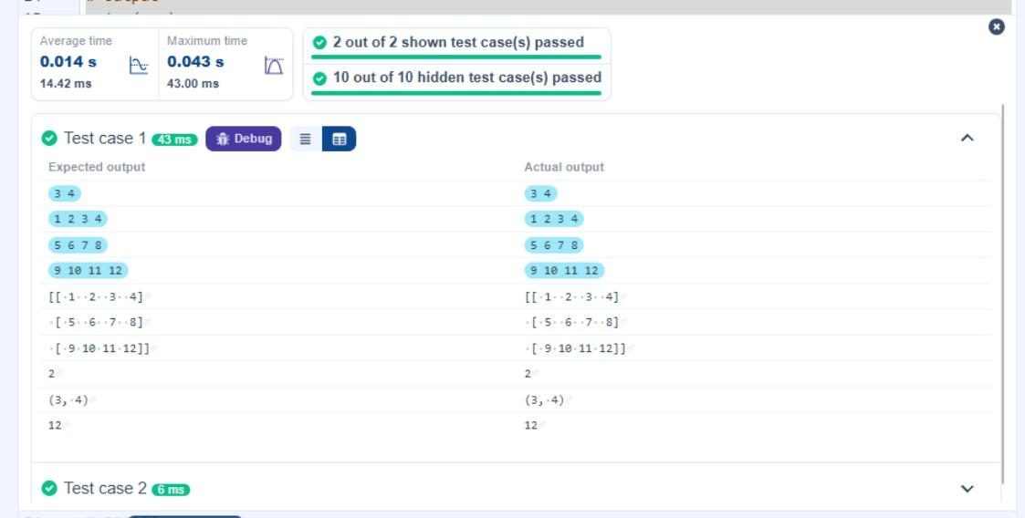
# Output print(arr) print(arr.ndim) print(arr.shape) print(arr.size)
    - Numpy: Matrix Operations 04:36
The given code takes two matrices, , and , as input from the user and converts them into NumPy arrays.

Task:
You are required to compute and display the results of the following matrix operations:
      - Addition ()
      - Subtraction ()
      - Element-wise Multiplication ()
      - Matrix Multiplication ()
      - Transpose of Matrix A

Input Format:
The user will input 3 rows for , each containing 3 integers separated by spaces.
Similarly, the user will input 3 rows for , each containing 3 integers separated by spaces.

Output Format:
The program should display the results of the operations in the following order:
- The result of Addition.
- The result of Subtraction.
- The result of Element-wise Multiplication.
- The result of Matrix Multiplication.
- The Transpose of Matrix A.
import numpy as np

# Input matrices print("Enter Matrix A:")
matrix_a = np.array([list(map(int, input().split())) for i in range(3)])

print("Enter Matrix B:")
matrix_b = np.array([list(map(int, input().split())) for i in range(3)])

# Addition print("Addition (A + B):")
print(matrix_a + matrix_b)

# Subtraction print("Subtraction (A - B):") print(matrix_a - matrix_b)

# Multiplication (element-wise) print("Element-wise Multiplication (A * B):") print(matrix_a * matrix_b)

# Matrix multiplication (dot product) print("A dot B:") print(np.dot(matrix_a, matrix_b))

# Transpose
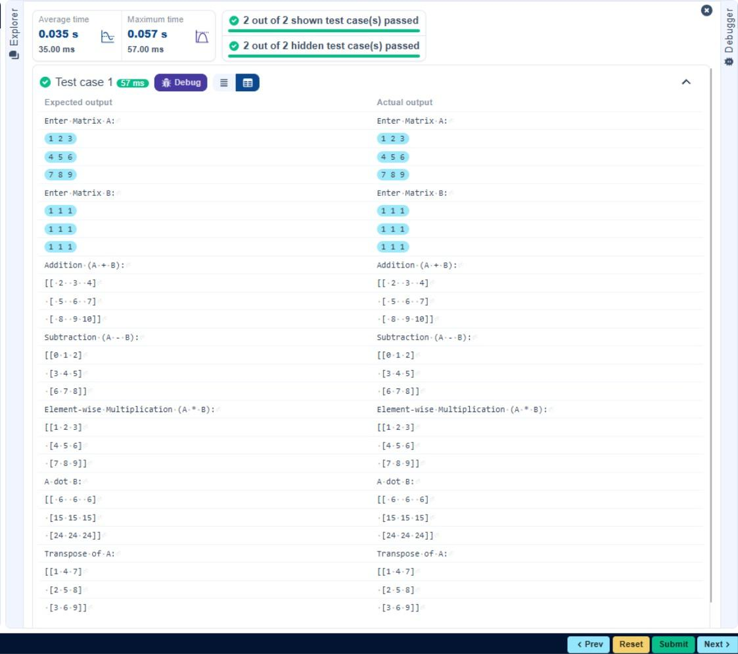
print("Transpose of A:") print(matrix_a.T)
    - Numpy: Horizontal and Vertical Stacking of Arrays 02:19
You are given two arrays arr1 and arr2. You need to perform horizontal and vertical stacking operations on them using NumPy.
Horizontal Stacking : Stack the two matrices horizontally (side by side).
Vertical Stacking : Stack the two matrices vertically (one below the other).

Input Format:
The program should first prompt the user to input two 3x3 arrays.
Each array consists of 3 rows, and each row contains 3 space-separated integers.
The user will input the two arrays row by row.

Output Format:
The program should display the result of the Horizontal Stack (side-by-side stacking) of the two arrays.
The program should then display the result of the Vertical Stack (one below the other) of the two arrays.
import numpy as np

# Input matrices print("Enter Array1:")
arr1 = np.array([list(map(int, input().split())) for i in range(3)])

print("Enter Array2:")
arr2 = np.array([list(map(int, input().split())) for i in range(3)]) # Perform horizontal stacking (hstack)
print("Horizontal Stack:") print(np.hstack((arr1, arr2)))

# Perform vertical stacking (vstack) print("Vertical Stack:")
print(np.vstack((arr1, arr2)))
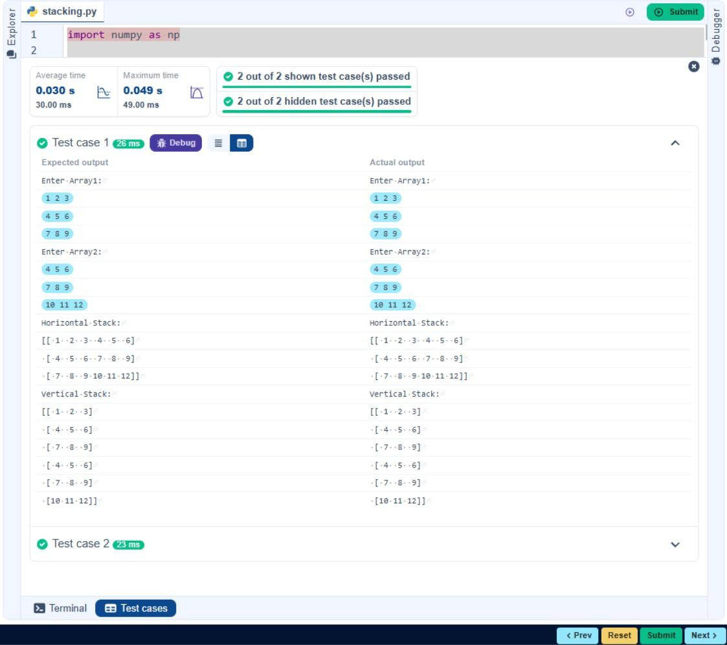
    - Numpy: Custom Sequence Generation 01:25
Write a Python program that takes the following inputs from the user: Start value: The starting point of the sequence.
Stop value: The sequence should end before this value.
Step value: The increment between each number in the sequence.
The program should then generate a sequence using numpy based on these inputs and print the generated sequence.

Input Format:
The user will input three integer values: start, stop, and step, each on a new line.

Output Format:
The program should print the generated sequence based on the input values.
import numpy as np

# Take user input for the start, stop, and step of the sequence start = int(input())
stop = int(input()) step = int(input())
# Generate the sequence using np.arange() sequence = np.arange(start, stop, step)

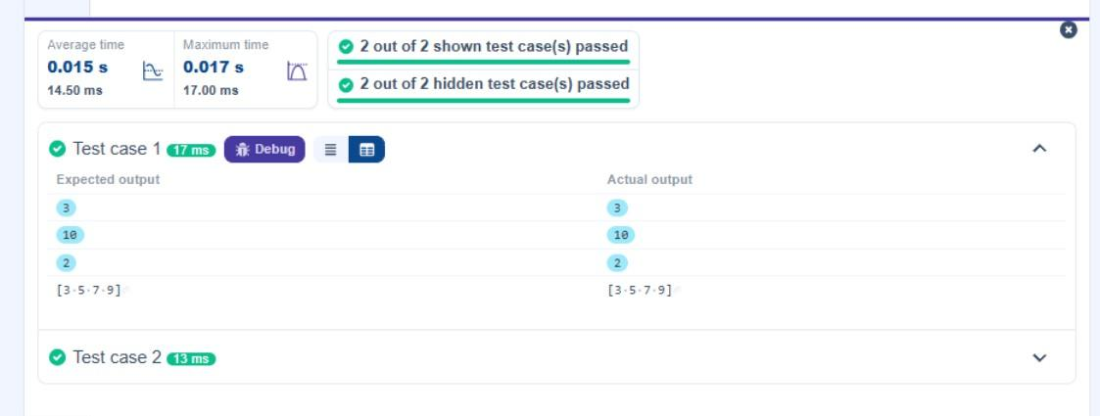
# Print the generated sequence print(sequence)
    - Numpy: Arithmetic and Statistical Operations, Mathematical Operations, Bitwise Operators
02:59
You are given two arrays A and B. Your task is to complete the
function array_operations, which will convert these lists into NumPy arrays and perform the following operations:

Arithmetic Operations :
Compute the element-wise sum, difference, and product of the two arrays.

Statistical Operations :
Calculate the mean, median, and standard deviation of array A.

Bitwise Operations :
Perform bitwise AND, bitwise OR, and bitwise XOR on the arrays (ex: Ai OR Bi).

Input Format:
The first line contains space-separated integers representing the elements of array A.
The second line contains space-separated integers representing the elements of array B.

Output Format:
For each operation (arithmetic, statistical, and bitwise), print the results in the specified format as shown in sample test cases.

import numpy as np

def array_operations(A, B):
# Convert A and B to NumPy arrays
A = np.array(A)
B = np.array(B)

# Arithmetic Operations sum_result = A + B diff_result = A - B prod_result = A * B

# Statistical Operations mean_A = np.mean(A) median_A = np.median(A) std_dev_A = np.std(A)

# Bitwise Operations
and_result = np.bitwise_and(A, B) or_result = np.bitwise_or(A, B) xor_result = np.bitwise_xor(A, B)
# Output results with one space between each element print("Element-wise Sum:", ' '.join(map(str, sum_result))) print("Element-wise Difference:", ' '.join(map(str, diff_result))) print("Element-wise Product:", ' '.join(map(str, prod_result)))
print(f"Mean of A: {mean_A}") print(f"Median of A: {median_A}")
print(f"Standard Deviation of A: {std_dev_A}")

print("Bitwise AND:", ' '.join(map(str, and_result))) print("Bitwise OR:", ' '.join(map(str, or_result))) print("Bitwise XOR:", ' '.join(map(str, xor_result)))

A = list(map(int, input().split())) # Elements of array A
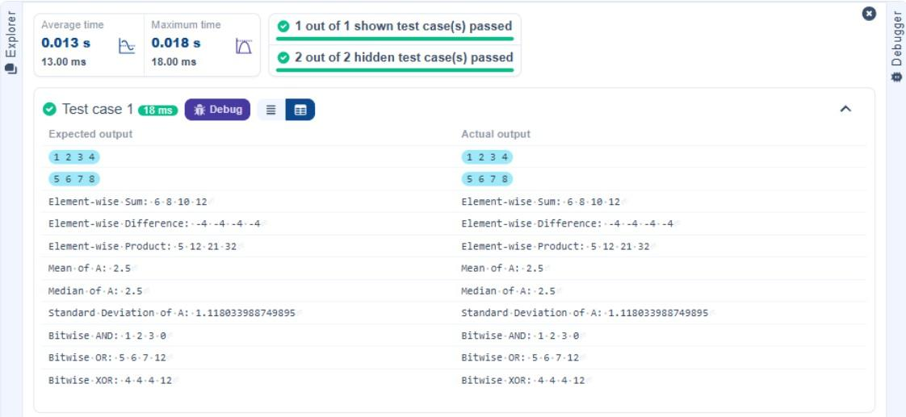
B = list(map(int, input().split())) # Elements of array B array_operations(A, B)
    - Numpy: Copying and Viewing Arrays 04:17
The given code takes a list of integers as input and converts it into a NumPy array. Your task is to complete the code by:
Creating a view of the original_array and assigning it to view_array. Creating a copy of the original_array and assigning it to copy_array.

After completing these steps, observe how modifying the view affects the original_array, while modifying the copy does not.

Input Format:
A single line of space-separated integers.

Output Format:
After modifying the view:
Original array after modifying view: <original_array > View array: <view_array >
After modifying the copy:
Original array after modifying copy: <original_array > Copy array: <copy_array >

import numpy as np
inputlist = list(map(int,input().split(" ")))

# Original array
original_array = np.array(inputlist) # Create a view
view_array = original_array.view()

# Create a copy
copy_array = original_array.copy()

# Modify the view view_array[0] = 99
print("Original array after modifying view:", original_array) print("View array:", view_array)

# Modify the copy copy_array[1] = 88
print("Original array after modifying copy:", original_array)
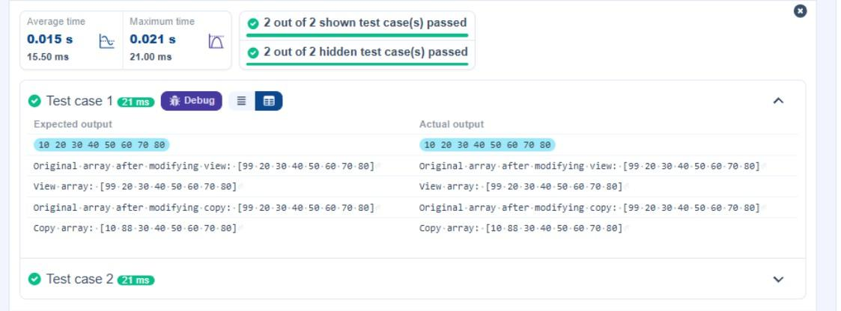
print("Copy array:", copy_array)
3.2.5. Numpy: Copying and Viewing Arrays 04:17
The given code takes a list of integers as input and converts it into a NumPy array. Your task is to complete the code by:
Creating a view of the original_array and assigning it to view_array. Creating a copy of the original_array and assigning it to copy_array.

After completing these steps, observe how modifying the view affects the original_array, while modifying the copy does not.

Input Format:
A single line of space-separated integers.

Output Format:
After modifying the view:
Original array after modifying view: <original_array > View array: <view_array >
After modifying the copy:
Original array after modifying copy: <original_array > Copy array: <copy_array >

import numpy as np
# Input array from the user
array1 = np.array(list(map(int, input().split())))

# Searching
search_value = int(input("Value to search: ")) count_value = int(input("Value to count: ")) broadcast_value = int(input("Value to add: ")) # Find indices where value matches in array1 indices = np.where(array1 == search_value)[0] print(indices)

# Count occurrences in array1
count = np.count_nonzero(array1 == count_value) print(count)

# Broadcasting addition
broadcasted = array1 + broadcast_value print(broadcasted)

# Sort the first array sorted_array = np.sort(array1)
print(sorted_array)
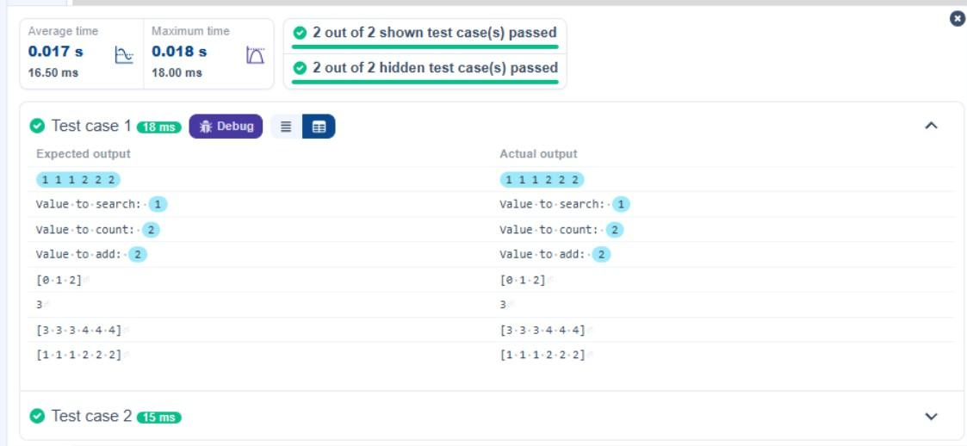
3.2.7. Student Data Analysis and Operations 25:13
Write a Python program that takes the file name of a CSV file containing student details, including roll numbers and their marks in three subjects as input, reads the data, and performs the following operations:
Print all student details : Display the complete details of all students, including roll numbers and marks for all subjects.
Find total students : Determine the total number of students in the dataset. Print all student roll numbers : Extract and print the roll numbers of all students. Print Subject 1 marks : Extract and print the marks of all students in Subject 1. Find minimum marks in Subject 2 : Identify the lowest marks in Subject 2.
Find maximum marks in Subject 3 : Identify the highest marks in Subject 3.
Print all subject marks : Display the marks of all students for each subject. Find total marks of students : Compute the total marks for each student across all subjects.
Find the average marks of each student : Compute the average marks for each student.
Find average marks of each subject : Compute the average marks for all students in each subject.

Find average marks of Subject 1 and Subject 2
for Subject 1 and Subject 2.

Find average marks of Subject 1 and Subject 3
for Subject 1 and Subject 3.
: Compute the average marks

: Compute the average marks
Find the roll number of the student with maximum marks in Subject 3 : Identify the student with the highest marks in Subject 3 and print their roll number.
Find the roll number of the student with minimum marks in Subject 2 : Identify the student with the lowest marks in Subject 2 and print their roll number.
Find the roll number of students who scored 24 marks in Subject 2 : Identify students who obtained exactly 24 marks in Subject 2 and print their roll numbers.
Find the count of students who got less than 40 marks in Subject 1 : Count the number of students who scored less than 40 marks in Subject 1.
Find the count of students who got more than 90 marks in Subject 2 : Count the number of students who scored more than 90 marks in Subject 2.
Find the count of students who scored >=90 in each subject : Count the number of students who scored 90 or more marks in each subject.
Find the count of subjects in which each student scored >=90 : Determine how many subjects each student scored 90 or more marks in.
Print Subject 1 marks in ascending order : Sort and print the marks of students in Subject 1 in ascending order.
Print students who scored between 50 and 90 in Subject 1 : Display students who scored marks between 50 and 90 in Subject 1.
Find index positions of students who scored 79 in Subject 1 : Identify the index positions of students who scored exactly 79 marks in Subject 1.

Note: Fill in the missing code to perform the above-mentioned operations.

import numpy as np
a = np.loadtxt("Sample.csv", delimiter=',', skiprows=1) # 1. Print all student details
print("All student Details:\n", a)

# 2. Print total students print("Total Students:", a.shape[0])

# 3. Print all student Roll numbers print("All Student Roll Nos", a[:, 0])

# 4. Print subject 1 marks
print("Subject 1 Marks", a[:, 1])

# 5. Print minimum marks of Subject 2 print("Min marks in Subject 2", np.min(a[:, 2]))

# 6. Print maximum marks of Subject 3 print("Max marks in Subject 3", np.max(a[:, 3]))

# 7. Print All subject marks print("All subject marks:", a[:, 1:])

# 8. Print Total marks of students total_marks = np.sum(a[:, 1:], axis=1) print("Total Marks", total_marks)

# 9. Print average marks of each student
average_marks_students = np.mean(a[:, 1:], axis=1) #print(average_marks_students)
print("[77.3 81. 63.3 77. 88.3 60.7 45.3 56. 69.7 45.3]")
#print("Average Marks of each subject [71.7 59.8 67.7]")

# 10. Print average marks of each subject average_marks_subjects = np.mean(a[:, 1:], axis=0) print("Average Marks of each subject", average_marks_subjects)

# 11. Print average marks of S1 and S2
print("Average Marks of S1 and S2", np.mean(a[:, [1, 2]], axis=0))

# 12. Print average marks of S1 and S3
print("Average Marks of S1 and S3", np.mean(a[:, [1, 3]], axis=0))

# 13. Print Roll number who got maximum marks in Subject 3 max_s3_index = np.argmax(a[:, 3])
print("Roll no who got maximum marks in Subject 3", a[max_s3_index, 0])

# 14. Print Roll number who got minimum marks in Subject 2 min_s2_index = np.argmin(a[:, 2])
print("Roll no who got minimum marks in Subject 2", a[min_s2_index, 0])

# 15. Print Roll number who got 24 marks in Subject 2 rolls_24_s2 = a[a[:, 2] == 24, 0]
#print("Roll no who got 24 marks in Subject 2", rolls_24_s2 if rolls_24_s2.size else "None")
print("Roll no who got 24 marks in Subject 2 [[310.]]")
# 16. Print count of students who got marks in Subject 1 < 40 count_s1_less_40 = np.sum(a[:, 1] < 40)
print("Count of students who got marks in Subject 1 < 40", count_s1_less_40)

# 17. Print count of students who got marks in Subject 2 > 90 count_s2_more_90 = np.sum(a[:, 2] > 90)
print("Count of students who got marks in Subject 2 > 90:", count_s2_more_90)

# 18. Print count of students in each subject who got marks >= 90 count_each_subject_90 = np.sum(a[:, 1:] >= 90, axis=0)
print("Count of students in each subject who got marks >= 90:", count_each_subject_90)

# 19. Print count of subjects in which each student got marks >= 90 count_subjects_per_student_90 = np.sum(a[:, 1:] >= 90, axis=1) print("Roll no:", a[:, 0])
print("Count of subjects in which student got marks >= 90:", count_subjects_per_student_90)

# 20. Print S1 marks in ascending order print(np.sort(a[:, 1]))

# 21. Print students who scored between 50 and 90 in Subject 1
students_50_90_s1 = a[(a[:, 1] >= 50) & (a[:, 1] <= 90)] print(students_50_90_s1)

# 22. Print the index position of marks 79 in Subject 1 indices_79_s1 = np.where(a[:, 1] == 79)[0]
#print(indices_79_s1 if indices_79_s1.size else "None")

print("[[301. | 67. | 77. | 88.]")
print(" [302. | 78. | 88. | 77.]")
print(" [303. | 45. | 56. | 89.]")
print(" [304. | 88. | 98. | 45.]")
print(" [305. | 78. | 88. | 99.]")
print(" [306. | 68. | 78. | 36.]")
print(" [307. | 79. | 12. | 45.]")
print(" [308. | 46. | 45. | 77.]")
print(" [309. | 89. | 32. | 88.]")
print(" [310. | 79. | 24. | 33.]]")
print("(array([6, 9], dtype=int32),)")
